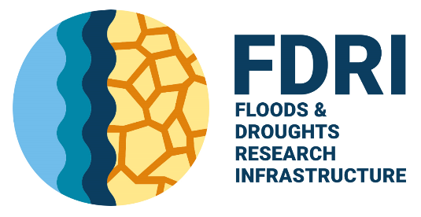
Application Form for FDRI PhD Support

Please complete this form to apply for FDRI support for a PhD project. The application form is designed for PhD proposals that would be advertised this Autumn and start in September 2026.
The UK Floods and Droughts Research Infrastructure (FDRI) project is a capital investment by UK Research and Innovation (UKRI) enabling essential science and innovation to improve the country’s resilience to hydrological extremes.
A core part of the FDRI capacity building programme is fostering the development of the next generation of early career hydrologists. To achieve this, we are looking to develop collaborative PhD projects aligned with the FDRI project. FDRI support for PhD studentship projects includes:
- Support and expertise from someone affiliated with the FDRI project
- £5,000 in total towards the PhD studentship
- Opportunities for placements at UK Centre for Ecology & Hydrology or the British Geological Survey
- Access to training, facilities, and expertise across the FDRI project
Proposed projects must include input from someone affiliated with the FDRI project (this could be co-supervision or more general input and support). Projects that have been co-created with FDRI team members and make use of or develop FDRI infrastructure (fixed, mobile or digital) will be prioritised for funding.
These initial projects will take place while core monitoring infrastructure is being designed and installed, but opportunities to partner with FDRI could include: understanding and characterising FDRI catchments in the wider UK context, developing innovative low cost sensors for hydrological monitoring, creating resilient catchments through citizen science, applying innovative digital approaches for analysis of early FDRI outputs including legacy catchment monitoring datasets and UK wide high resolution rainfall, evaporation, river and flow data.
If you have an exciting project idea but unsure of the opportunities that FDRI could offer, please contact Jonathan Evans (jge@ceh.ac.uk) for observatory (fixed/mobile) infrastructure, Matt Fry (mfry@ceh.ac.uk) for digital infrastructure and Wouter Buytaert (w.buytaert@imperial.ac.uk) for projects related to innovation. If you have any other questions, please contact Gemma Coxon (gemma.coxon@bristol.ac.uk).
Please send your completed forms to fdri@ceh.ac.uk by with the email subject ‘Application Form for FDRI PhD Support’.

Studentship Details
Name of FDRI Supervisor(s)
Which work package is your FDRI supervisor mainly aligned with? | Choose an item.
University managing the Studentship
Name of University Supervisor(s) and Institution
Name of Industry Supervisor(s) and Organisation
PhD Start Date
PhD Duration
Please identify the main source of funding the University supervisor will be applying for (e.g. NERC DTP or CDT, EPSRC CDT, University Scholarship)
Please detail and justify how you would like to spend the £5,000 contribution (i.e. match funding, enhancement of stipend, for equipment, travel, subsistence)
PhD Project Title

Project Details
Please provide a summary of the PhD project including the rationale, project aims and methods.
Max 250 words

FDRI Links
Please provide a summary of how the PhD project links with FDRI. Please provide details of any specific facilities/training needs required from FDRI (including approximate dates if important for the project).
Max 250 words

Applications and their data will be managed according to UK CEH data policy and EDI policy.

